T

Schema-Driven Editor Requirements

Product Suite | TIBCO BusinessEvents
Product | TIBCO BusinessEvents
Product Version | 4.0
Initial Author | Nicolas Prade

Copyright Notice
COPYRIGHT© 2008-2009 TIBCO Software Inc. This document is unpublished and the foregoing notice is affixed to protect TIBCO Software Inc. in the event of inadvertent publication. All rights reserved. No part of this document may be reproduced in any form, including photocopying or transmission electronically to any computer, without prior written consent of TIBCO Software Inc. The information contained in this document is confidential and proprietary to TIBCO Software Inc. and may not be used or disclosed except as expressly authorized in writing by TIBCO Software Inc. Copyright protection includes material generated from our software programs displayed on the screen, such as icons, screen displays, and the like.
Trademarks
Technologies described herein are either covered by existing patents or patent applications are in progress. All brand and product names are trademarks or registered trademarks of their respective holders and are hereby acknowledged.
Confidentiality
The information in this document is subject to change without notice. This document contains information that is confidential and proprietary to TIBCO Software Inc. and may not be copied, published, or disclosed to others, or used for any purposes other than review, without written authorization of an officer of TIBCO Software Inc. Submission of this document does not represent a commitment to implement any portion of this specification in the products of the submitters.
Content Warranty
The information in this document is subject to change without notice. THIS DOCUMENT IS PROVIDED "AS IS" AND TIBCO MAKES NO WARRANTY, EXPRESS, IMPLIED, OR STATUTORY, INCLUDING BUT NOT LIMITED TO ALL WARRANTIES OF MERCHANTABILITY OR FITNESS FOR A PARTICULAR PURPOSE. TIBCO Software Inc. shall not be liable for errors contained herein or for incidental or consequential damages in connection with the furnishing, performance or use of this material.
For more information, please contact:
TIBCO Software Inc.
3303 Hillview Avenue
Palo Alto, CA 94304
USA
Table of Contents
Change Log 5
1.1 Related Documents 5
2 Introduction 6
2.1 Purpose 6
2.2 Scope 6
2.3 Audience 6
2.4 References 6
3 Acronyms and Vocabulary 7
4 Overview 8
4.1 Goal 8
4.2 Examples 8
5 API 9
5.1 Framework 9
5.1.1 Java Swing 9
5.2 Configuration invariants 9
5.2.1 XSD documents 9
5.2.2 Main path 9
5.2.3 XML document 10
5.2.4 Style sheets 10
5.3 Changes 10
5.3.1 XSD documents 10
5.3.2 Main path 10
5.3.3 XML document 10
5.3.4 Style sheets 11
5.4 Output 11
5.4.1 XSD documents 11
5.4.2 Main path 11
5.4.3 XML document 11
5.4.4 Style sheets 11
6 Default Rendering 12
6.1 Nodes forbidden by the main path 12
6.1.1 => No UI. 12
6.2 Any component with a Particle 12
6.2.1 [0,0] => no UI 12
6.2.2 [1,1] => present the UI for the particle term (i.e. ignore that there is a particle). 12
6.2.3 [0,1] => present a checkbox, or similar toggle-type UI, and the UI for the particle term. 12
6.2.4 Other => present a list editor, or similar, with a block UI for the particle term — the editor must enforce the minimum and maximum number of occurrences 13
6.3 Root elements 13
6.3.1 No root element in the schema => no UI 13
6.3.2 One root element => same as a non-root element 13
6.3.3 Multiple root element‘s => same as choice 13
6.4 Non-root elements 13
6.4.1 Content fully fixed => no UI 13
6.4.2 Some variable content => present a label with the element name (perhaps followed by a colon) and the UI for its content 13
6.5 Element attributes 14
6.5.1 Fixed => no UI 14
6.5.2 Variable => present a label for the attribute and a UI for the typed value of the attribute 14
6.6 XML text or mixed content 14
6.6.1 Fixed => no UI 14
6.6.2 Variable => present an editor for the typed value of the XML text (or mixed content) as shown below 14
6.7 Typed Value 14
6.7.1 No pattern or enumeration => present an editor for the base simple type 14
6.7.2 pattern => present an editor for the base simple type, with a validator 14
6.7.3 enumeration => present a single-lined selection UI with each possible value 14
6.8 Compositor 15
6.8.1 all => same as sequence 15
6.8.2 sequence => present the UI for each particle 15
6.8.3 choice => present a list editor, or similar, with a block UI for each particle term — the editor must enforce the minimum and maximum number of occurrences 15
6.9 Substitution Group 15
7 Style Sheets 16
7.1 Style sheet 16
7.1.1 Syntax TBD 16
7.2 Node Selector 16
7.2.1 Syntax TBD 16
7.3 Rendering instructions identifier 16
7.3.1 Capabilities 16
7.3.2 Syntax TBD 16

Change Log
.
Date | Version | Name | Description
7/13/09 | 0.1 | Nicolas Prade | Initial Document Creation
7/14/09 | 0.2 | Nicolas Prade,  Sridhar Sailappan | Refined, added rendering examples.

Related Documents
Document Title | Revision Number | Author
TIBCO BusinessEvents User Guide | 3.0 | Jackie Pascoe
XML Schema Part 1: Structures Second Edition | 1-20041028 | W3C
Extensible Markup Language (XML) 1.0 | 1.0 20081126 | W3C
XML Path Language (XPath) Version 1.0 | 1.0 19991116 | W3C

Introduction

Purpose
This document defines the requirements for a schema-driven editor. This editor is to be used in several areas of the TIBCO BusinessEvents 4.0 user interface.

Scope
Functional requirements of the schema-driven editor.
Compatibility requirements.
Design and implementation constraints if any.

Audience
Developers
Architects
Quality Assurance
Product Marketing
Product Management
Support.

References

Acronyms and Vocabulary

The table below describes some of the acronyms used in this documentation
- BE – TIBCO BusinessEvents.
- XML – Extensible Markup Language.
- XSD – XML Schema Definition.
- XPath – Xml Path.
- UI – User Interface.
- Designer – The design tool of BE 3.x. In BE 4.0, it is replaced with eclipse.
- Shared Resource – One of the documents used in BE. There are several types of Shared Resources. Not all documents used in BE are Shared Resources.
- Deployment Config – One of the documents used in BE.

Overview

Goal
We want a Swing component which allows an end-user to achieve the constrained update of an XML document.
The component’s data model must be configurable at runtime, through APIs, with
- a set of XML schemas, which define a set of valid combinations of XML nodes and text content,
- the path to an XML element which must exist in one of the configured schemas,
- an XML document which must contain a node matching the configured element path.
The component must ensure that the XML document validates and includes an element at the configured path.
The component must generate its own UI automatically, based on the configured node and the schemas in use.
The component must enable the end-user to build most of the combinations allowed by the current combination of XML schema and configured element path (if possible, all the combinations).
The component’s UI must be configurable at runtime, through APIs, to allow optional customization of its rendering, by associating custom rendering classes to parts of the component UI through the use of style sheets.
This component is intended to be integrated in Eclipse, on which BE Studio is based.

Examples
Tbd.

API

Framework

Java Swing

The editor is an eclipse component or a Java Swing component.

The editor should preferably not require any platform-dependant components, such as native libraries.

Configuration invariants
An instance of the editor can be configured with these parameters:

XSD documents

XSD documents are schemas that help define the valid values for the edited document.

There may be zero, one or more XSD documents.

XSD documents are read-only.

XSD documents must be valid.

Each XSD document should have a unique namespace (i.e. no conflict).

XSD documents may reference one another.

Main path

The main path is an XPath string that identifies an element node that must always be included in the edited document.
The purpose of this main path is to identify which subset of which schema is to be enforced in the XML document.
For example, the main path may force the XML document to include the node /BWSharedResource from the http://tibco.com/be/shared/jms namespace. This way, the editor is not allowed to let the user modify the XML into another type of document, such as an RV transport shared resource.

There must be zero or one main path.

The main path is forbidden if no XSD or no edited document is specified.

The main path is mandatory if an edited document is specified.

The main path must be valid (i.e. can be resolved in the context of the set of XSD Documents).

XML document

The XML document is the document rendered and updated by the editor.

There must be zero or one XML document.

The XML document is forbidden if no main path or no XSD is specified.

The XML document is mandatory if a main path is specified.

The XML document, if it exists, must include the element specified by the main path.

The XML document must be valid.

The XML document is mutable.

Style sheets

The style sheets specify zero, one or more custom rendering instructions that are applicable to either the currently edited document or to some other document.

There may be zero style sheets, one style sheet, or a list of style sheets. The style sheet order determines the precedence of the rendering instructions.

The style sheets are read-only.

Changes
An editor can be modified as follows:

XSD documents

XSD documents may be added or removed at any time. Though, in a first phase, it is ok to allow it only if there is no main path (and XML document).

Main path

The main path can be removed at any time. The configuration rules must be verified, which implies that the XML document has to be removed at the same time as the main path.

The main path can be replaced at any time. The configuration rules imply that the new path must be valid, and that the XML document is also replaced at the same time with an XML document that contains the node specified by the new main path (this could be the same XML document).

XML document

The XML document can be removed at any time. The configuration rules imply that the main path is also removed at the same time.

The XML document can be modified at any time. The configuration rules imply that the new version must contain the node specified by the main path, and be valid.

The XML document can be replaced at any time. The configuration rules imply that the new XML document must be valid and must contains the node specified by the new main path.

Style sheets

The style sheets may be added or removed at any time. Though, in a first phase, it is ok to allow it only if there is no main path (and XML document).

Output
The editor can be queried for the following information:

XSD documents

The current set of XSD documents can be read.

Main path

The current value of the main path can be read.

XML document

The current XML document can be read.

Style sheets

The current set of style sheets can be read.

Default Rendering

The rendering follows the XML structure as constrained by the XSDs.

Nodes forbidden by the main path
Model groups may include nodes whose presence would prevent the existence of the element node required by the main path.

=> No UI.
Those nodes should not be mapped to any UI.
For example: When the main path passes through a choice node, the choice child selected by the main path is the only node that can satisfy the configuration requirement. Therefore the other choice children should have no UI, in this context. Not that if the same choice node, from the same schema, is later reused, in the same document, in a different context where all the choice children are valid, then in this all these children may have a UI in this other context.
Subsequent statements assume that nodes have been verified for compatibility with the main path, so forbidden nodes are not considered.

Any component with a Particle

[0,0] => no UI

[1,1] => present the UI for the particle term (i.e. ignore that there is a particle).

[0,1] => present a checkbox, or similar toggle-type UI, and the UI for the particle term.

If possible, it might be good to show the particle term only when the box is checked.
Example: The Description node is marked as [0,1]:
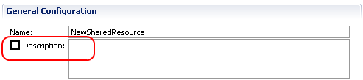

Other => present a list editor, or similar, with a block UI for the particle term — the editor must enforce the minimum and maximum number of occurrences
Example: The node labeled as “Application Properties” is marked [0,*].
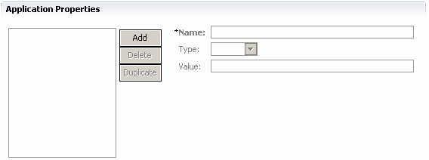

Root elements

No root element in the schema => no UI

One root element => same as a non-root element

Multiple root element‘s => same as choice

Non-root elements

Content fully fixed => no UI

Some variable content => present a label with the element name (perhaps followed by a colon) and the UI for its content

Example: The “Name” element has been found. A label has been created for it, and the UI for the element content (determined elsewhere) happens to be a text box.
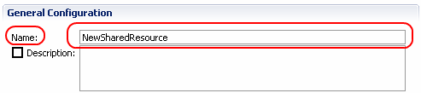

Element attributes

Fixed => no UI

Variable => present a label for the attribute and a UI for the typed value of the attribute
Example: The Driver element has two attributes, “Name” and “URL”:

XML text or mixed content

Fixed => no UI

Variable => present an editor for the typed value of the XML text (or mixed content) as shown below

Typed Value

No pattern or enumeration => present an editor for the base simple type
Example: The node “Timeout” is of type int:

pattern => present an editor for the base simple type, with a validator
Example: The node “Port” is of type int, with a pattern of “[0-9]+”:

enumeration => present a single-lined selection UI with each possible value
Example: The node labeled “Credential Type” is restricted by an enumeration, and its current value is “Keystore”:
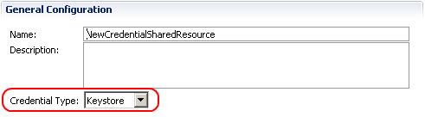

Compositor

all => same as sequence

sequence => present the UI for each particle
Example: The “JDBC” node contains a sequence which has four particles whose terms are elements respectively named “JDBC Driver”, “Database URL”, “UserName” and “Password”:
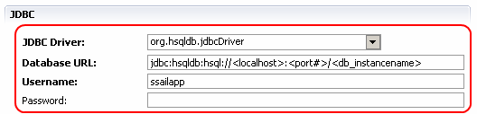

choice => present a list editor, or similar, with a block UI for each particle term — the editor must enforce the minimum and maximum number of occurrences
Example: The choice contains three options: “First”, “Second” and “Third”. Option “Second” is the current value and happens to contain the elements “Name”, “Type” and “Value” (other options may contain something else):
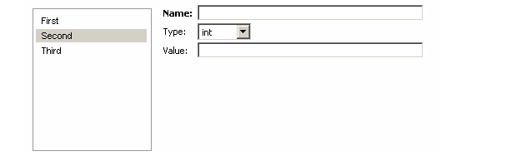
TBD: Where to get the option names?

Substitution Group
TBD

Annotation
TBD

Style Sheets

Style sheet
A Style sheet is a list of associations of one node selector to one (TBD or 0-*?) rendering instructions identifier, as follows:

Syntax TBD

Node Selector
Selectors are used to locate one or more node(s) in the XML. TBD: or is it in the XSD instead?

Syntax TBD

Rendering instructions identifier
Rendering instructions identifiers are used to locate the custom code that can render the selected node(s).

Capabilities
TBD

Hide the current node but not its children
Example: Hide the name of the root node.

Hide a node tree
Example: Hide a node tree and always set a fixed value in the corresponding XML, even if the schema allows for multiple possible values.

Replace the default UI for a given structural element with a custom java component.
TBD: Define the APIs that the custom components will need to implement
Examples: Replace a list selector with radio buttons. Replace a string field with a label + browse button that allows the user to browse the eclipse project for a reference. Not that it might be good to provide OOB a set of useful replacement components.

Create extra UI components, which are not modifying the XML document.
Examples: Create collapsible sections to enclose groups of UI components. Create a “Test Connection” button that reads some of the XML document and uses it in test code.

Relocate UI components.
Example: Force a UI component to appear under a specific collapsible section.

Etc.

Syntax TBD

